**AWS Trusted Advisor**

**AWS Trusted Advisor**

**[AWS Trusted Advisor](https://aws.amazon.com/premiumsupport/technology/trusted-advisor/" \t "_blank)** is a web service that inspects your AWS environment and provides real-time recommendations in accordance with AWS best practices.

Trusted Advisor compares its findings to AWS best practices in five categories: cost optimization, performance, security, fault tolerance, and service limits. For the checks in each category, Trusted Advisor offers a list of recommended actions and additional resources to learn more about AWS best practices.

The guidance provided by AWS Trusted Advisor can benefit your company at all stages of deployment. For example, you can use AWS Trusted Advisor to assist you while you are creating new workflows and developing new applications. Or you can use it while you are making ongoing improvements to existing applications and resources.

**AWS Trusted Advisor Dashboard**

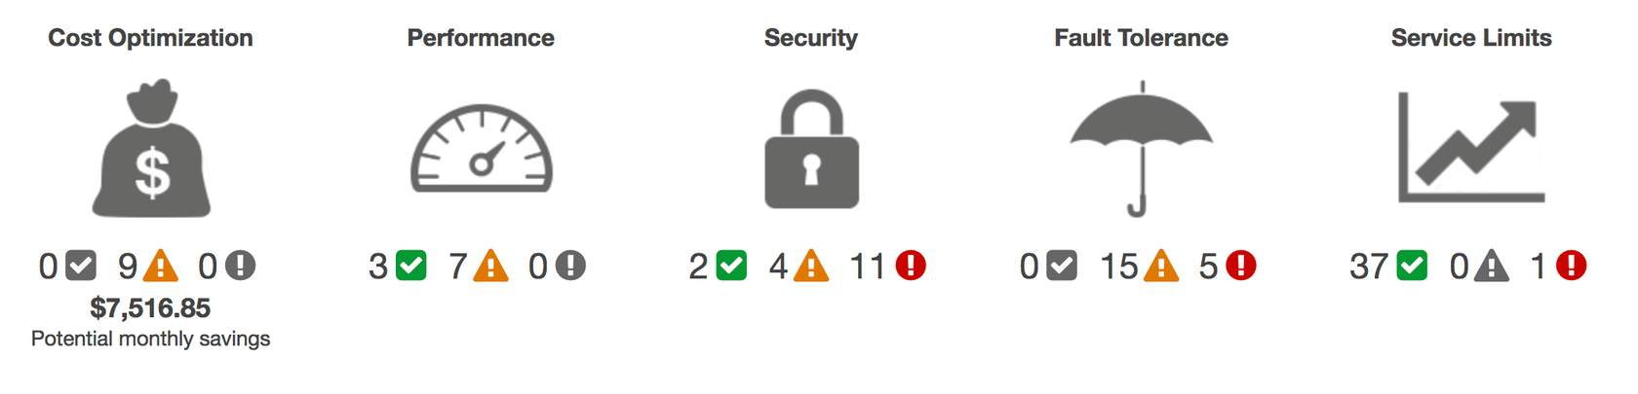

When you access the Trusted Advisor dashboard on the AWS Management Console, you can review completed checks for cost optimization, performance, security, fault tolerance, and service limits.

For each category:

* The green check indicates the number of items for which it detected **no problems**.
* The orange triangle represents the number of recommended **investigations**.
* The red circle represents the number of recommended **actions**.